THE BEXHILL ART SOCIETY BULLETIN – February 2024
Hello dear Members – welcome to your first BAS Bulletin for 2024! This will also be the last Bulletin that I personally will be creating as there is now a new Committee in place, who may take up the reins. I do hope that you’ve enjoyed reading the monthly Bulletin throughout 2023 as much as I enjoyed putting it together for you. Looking back, there have been some lovely moments to share - great artwork, super photos and happy memories.
So – it's all change at Bexhill Art Society – exciting news, with a new Committee in place! Read below for further details. It means that after a trepidatious few weeks, BAS can carry on securely– great stuff!
Speaking on behalf of myself and the rest of the outgoing Committee – thanks for your time and your support and we wish the new Committee and BAS every success for the future!
Val Sprott – Acting Chair (Outgoing)
Saturday 3 February AGM
It was great to see such a good turnout for the AGM. There is rather more information available in the Minutes for the AGM which are attached but in brief:
Both the founder of BAS Terry Carter and the Patron, Jayne Ingles were present at the AGM

During 2023, membership figures had grown. Demonstrations had been well attended, workshops less so.

The BAS Summer Exhibition at the De La Warr Studio had been very successful. resulting in a profit despite the high cost of hiring the De La Warr. Val thanked all those who had worked to make the Exhibition a success.

The Christmas Social had been well attended, a wide range of entries were submitted for the Members Competition and both the Quiz and buffet went down very well.

BAS at the moment, is in a good position to continue into 2024, both financially and practically. However, Rother Council had indicated that the Grant applied for and received in former years, (£1,000) would no longer be available due to cutbacks.

She thanked the Committee for the work that they had undertaken during 2023 and also expressed gratitude to the volunteers who had supported BAS and the Committee throughout 2023 as well as the contributions from the Artists of the Month during 2023.

Val stated that, speaking personally it had been a privilege to have the opportunity to serve on the Committee during 2022 and 2023.

The Treasurer’s Report confirmed that the year ended with a healthy balance of £3,879.26. A surplus of £113.91 on the previous year’s closing accounts. Again, more details are available in the attached minutes of the AGM and also in the folder available to read at each meeting.
The New Committee
The Outgoing Committee, Val Sprott, Marilia Whittome and Claudie Harbour stepped down. Carol Theron remained as Membership Secretary. The new Committee members who stepped forward at the AGM are:
Dennis Philpott Interim Chair
June Copleston Treasurer
Carol Theron Membership Secretary
Vayden Thomas Committee Member
Patricia Fishenden Committee Member
Most Volunteers, Jan McIntosh (Workshops and demonstrations), Julia Hall and Chris Verrijden (sales table) and Tim O’Sullivan (Sound) agreed to continue to provide their support to the new Committee. Our thanks to them and our very best wishes for every future success to the new Committee.
Bill Greenhead - Demonstrator
Following the AGM, Bill Greenhead, a BAS member, provided a lively, fast paced, witty and instructional demonstration on the art of drawing successful cartoons, discussing techniques and animation effects. His audience spent much time chortling over the way he created expressions and comic effects with just a few swift, well placed lines. Below are some images of Bill working on typical projects.
Members will also recall that Bill received the Mayor’s Choice award at the BAS De La Warr Studio exhibition in 2023 (shown below). In fact the Mayor liked his seagull so much, she bought it!

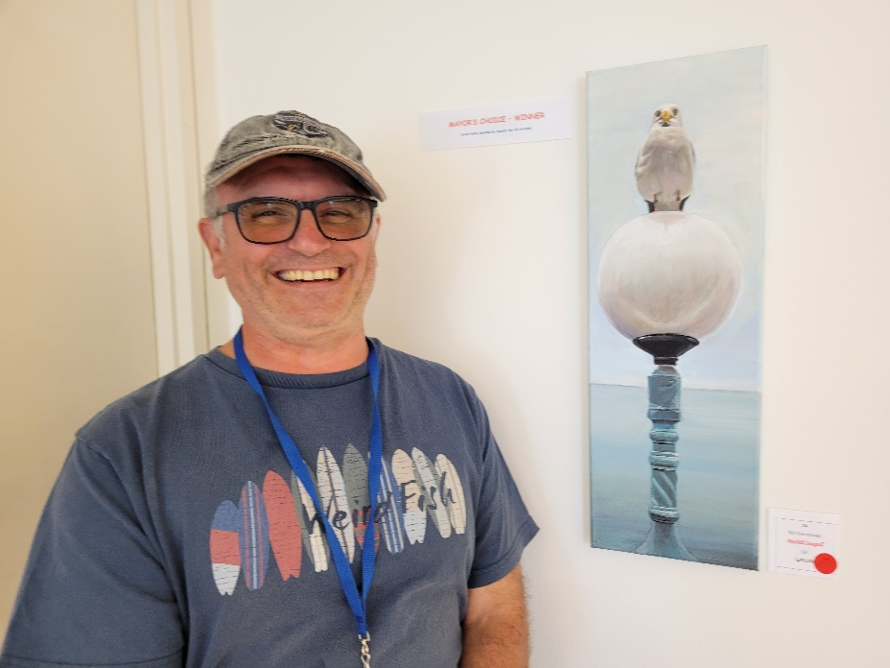

Bill Greenhead with his award winning painting

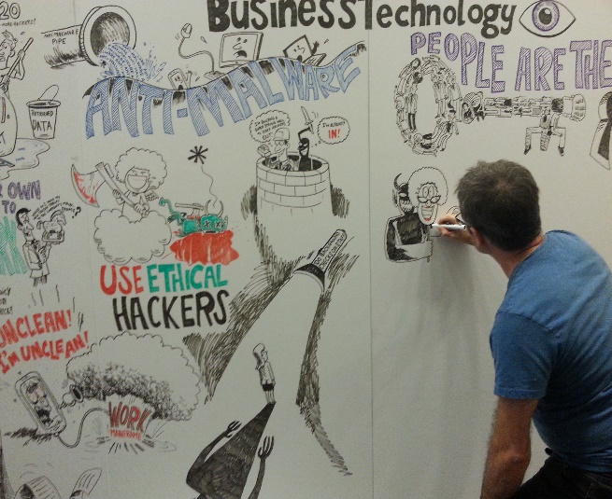 | 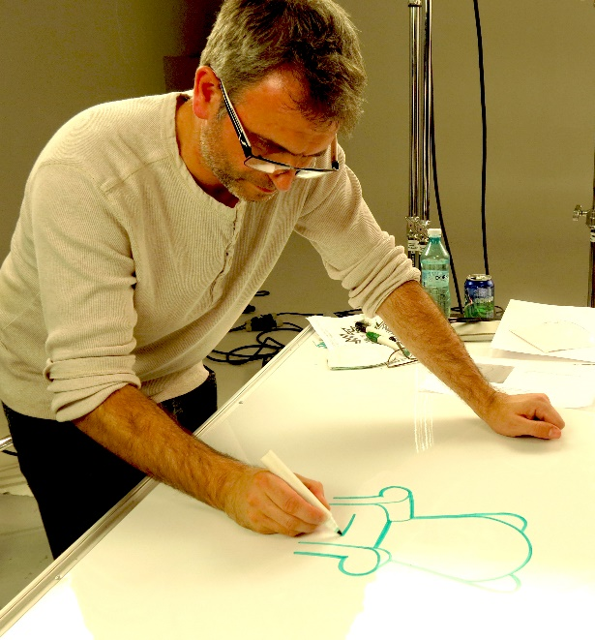

All the Members seemed to enjoy Bill’s demonstration greatly – caricature was also discussed and Bill explained how to capture the most salient features for any cartoon so that it, and the emotion and activity portrayed, were instantly recognisable.
Thank you Bill! Great fun!

OUR NEXT MONTHLY MEETING IS ON SATURDAY 2 MARCH
St Augustine’s Church Hall

With the immediate future of the Society now secure, it can be confirmed that the next meeting will take place on Saturday 2 March.

Membership Renewal

We are looking forward to welcoming you all back for another year of ‘splashing it on all over!’
The membership fee is £30 and you can pay by a number of ways. The easiest (for us) is by Bank Transfer. Account details are:
Account name: Bexhill Art Society
Account Number: 78472741
Sort code: 51-70-12

Otherwise you can pay on the day by card, cheque or cash.
In order to save time on 2nd March, and in an effort to cut into the Meeting as little as possible, please arrive from 1.30 onwards. Where possible, would you also please print off and complete the Renewal Form attached to the BAS BULLETIN before coming to the meeting as this will also otherwise slow down the process.
Demonstrator

The Demonstrator for March will be Sarah Flack, who will be demonstrating creating Still Life using Charcoal. This will be a two part session – Sarah will provide a still life and demonstrate in the first part prior to the refreshments break. During the second part, members are invited to take part themselves using dry materials – i.e. charcoal, pencils or pens – Sarah will ‘float’ to provide advice to members. This should therefore be a very fun and interactive session.

A little about Sarah herself:

Sarah Flack My artistic experience has covered a wide variety of disciplines and mediums, ranging from areas such as fine art, mechanical drawing and fashion design. This has enabled me to become a versatile artist. I have exhibited my work in London and the South East including at RK Burt, Southwark, St Martin in the Fields, Bodiam Castle, Greenstede Gallery, East Grinstead, Nevill Gallery, Canterbury, Fairfax Gallery and Blue Moon in Tunbridge Wells, The Studio, Otford, and in Hastings at the Stables Theatre, the Arts Forum and the Pier. I enjoy working instinctively and exploring a variety of technical challenges. Through a broad range of subject matter and an innovative approach, I love to push the boundaries. I feel this keeps my work fresh.

Artist of the Month

Jan McIntosh has kindly offered to be Artist of the Month for March. I’m sure most of us will have seen some of Jan’s work in the past and as you will recall, she won the Visitors Choice award at the BAS De La Warr Studio exhibition in 2023. We will all look forward to viewing some more of her lovely paintings.

Competition Theme

The theme for the monthly Competition will be SPRING. Well, it had to be, didn’t it? March, leaping lambs, catkins, daffodils and all that! But – of course – do keep in mind that there is more than one meaning for ‘Spring’ and that it’s also a verb as well as a noun! So – have fun, and let’s bounce into March!

How to contact Bexhill Art Society
Email: bexhillartsociety@hotmail.com

