Feedback from Visitors  Written feedback  (82 completed feedback slips were received)  Did you enjoy the exhibition: Responses in percentages  2 3 4 5 6 7 8 9  1% 4% 25% 35% 35%  What did you like about the exhibition?  Responses. Examples of themes:  Warm welcome. Nicely hung pictures. Paintings well displayed. Variety of original work. Professional quality. Wide range of styles and media. Perfect. Good lighting. Quality of work. Good showcase. Liked it all. Friendly faces.  What could be improved for future exhibitions?  Responses. Example of themes:  More paintings. Venue where you could have coffee and take time to enjoy the art. Nothing to improve. Perhaps a small commentary of each artist and their background. Put up photos of sold paintings, empty spaces are not nice. Have some background music.  Where did you hear about us?  Responses. Example of themes:  I am the founder – Terry Carter! From my aunt who lives locally! Local newsletter. Council website De La Warr Pavilion. Walked in from the road. Passing by. Word of mouth. Bexhill info. What’s on magazine. Online social media. Facebook.  Verbal feedback  (Welcome desk)  ” Where did you hear of the event?”  Promenade signs 84  Online 77  Just passing by 55  De La Warr 50  From BAS member 50  Word of Mouth 25  Other (local press, Rother) 20  BAS Exhibition - August 2023  Facts and Figures Summary  This outline includes Income and Expenditure, Visitors’ Feedback, Sponsorships and Award winners,  Other significant Figures.  One of the aims of the BAS Committee is to endeavour to cover costs without loss to the Society. Full expenditure coverage was achieved on this occasion (despite the hiring rates of the De La Warr Pavilion Studio),  and a surplus was realised!  Exhibition Sponsorships and Awards  - De La Warr Pavilion Choice: 1 Year DLWP membership - Val Sprott.  - Judges Printers Choice: Printing of 100 cards - Val Sprott.  - Mayor’s Choice (sponsored by the SAA): Painting set and brushes - Bill Greenhead.  - Visitors’ Choice, BAS cash Prize: £50 - Janet McIntosh.  - Rother District Council Grant: £1,000 - Bexhill Art Society.  Our Sponsors | Bexhill Art Society  Annual Exhibition  August 2023  Facts and figures  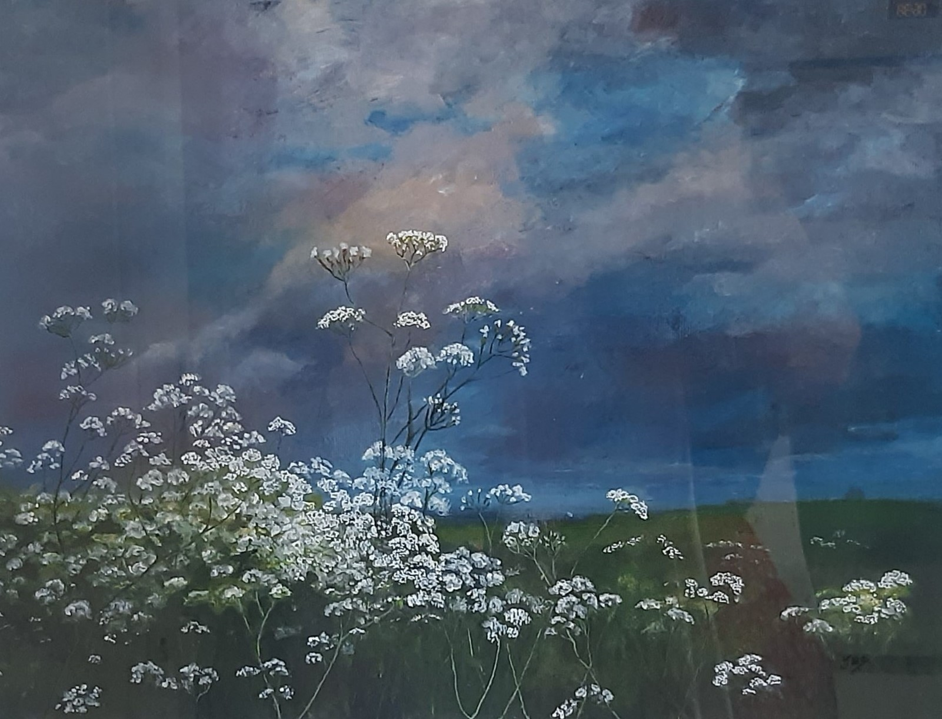  Visitors’ Choice  “There is a Storm Coming” by Jan McIntosh  Email address: bexhillartsociety@hotmail.com  Website: https://www.bexhillartsociety.com/  Facebook: https://www.facebook.com/bexhillartsociety/  Income and Expenditure  Income Expenditure  Exhibition entries £779 Printing £105  Hanging Art Sales £2460 Payment to Artists Hanging Art £1968  Browser Art Sales £397 Payment to Artists Browser Art £317.60  Cards Sales £352 Payment to Artists Cards £282  Raffle Sales £385 Miscellaneous £31  Total fees and sales £4373.50 Raffle Prize £30  Rother Council Grant £1000 Visitors’ Choice Prize £50  Sumup card fees £44.11  De La Warr Pavilion Hire £2244.00  Total Income £5373.50 Total Expenditure £5071.71  Surplus £301.79  Other figures  Footfall 1026  Number of exhibits entered (excluding cards) 136  Number of BAS Members entered 29  Number of Cards sold 141  Number of BAS Members who sold their artwork (Hanging, Browser or Cards) 21  Number of Hanging paintings sold 23  Number of Browser paintings sold 12  New memberships 6  Number of stewards at the Exhibition 19  