THE BEXHILL ART SOCIETY BULLETIN
December 2023
There was a great turnout for the final Meeting of 2023, the Christmas Social.
A competition with a number of categories for members work, plus an overall winner, a Christmas Quiz and a buffet of delectable nibbles all seemed to go down well with the Members. Pictures and story below.
In addition, there’s some more important stuff to read up on, so do take note!
Saturday 2 DECEMBER Monthly Meeting
It was a FREEZING day, with the addition later in the afternoon, of freezing fog. Lovely! There was a great turnout however, for the final session and it was equally great fun.
A goodly number of excellent paintings were put into the six categories for the Members Annual Competition . Members were invited to vote, and the winners were:
BRIGETTE HARPER - ABSTRACT  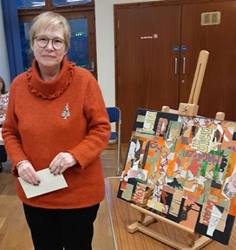 | JANIS LENN – PORTRAIT/PEOPLE  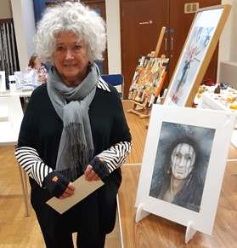
CHRIS VERRIJDEN - LANDSCAPE  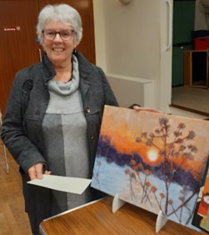 | DEE REEVES – ANIMALS  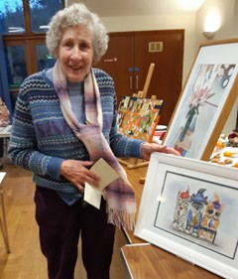
MARTIN SUTTON - SEASCAPE  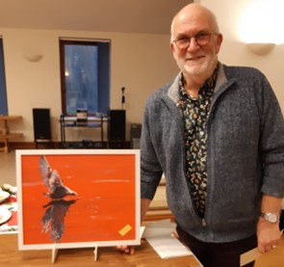 | SUSAN STACEY – FLOWERS/STILL LIFE  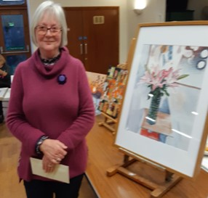

All winners won a £10 prize. From these six category winners, Members then voted for the Overall Winner. It was a tough choice as all the paintings were super for different reasons. However there was one clear winner.

OVERALL WINNER OF THE
2023 BAS MEMBERS ANNUAL COMPETITION
CHRIS VERRIJDEN

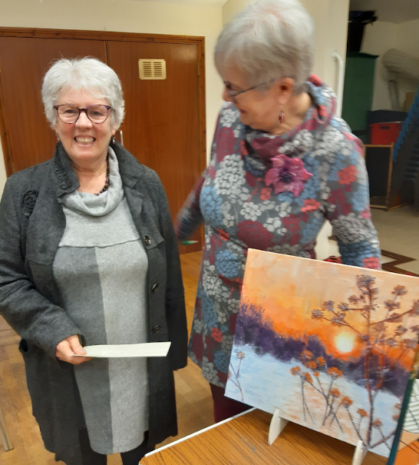 | 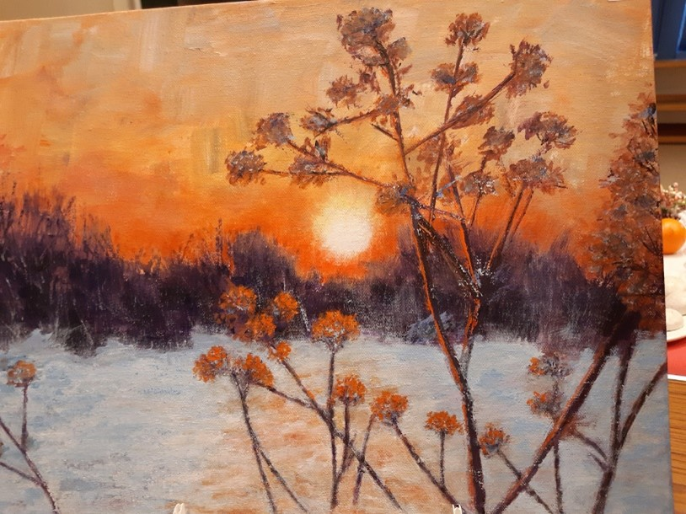

Very well done Chris! And well done, not only to our category Winners, but also to everyone who put in entries. They were all great, using a wide range of techniques and subject matter, and a few examples are shown below. There will be other photos on our Facebook page for you to enjoy.
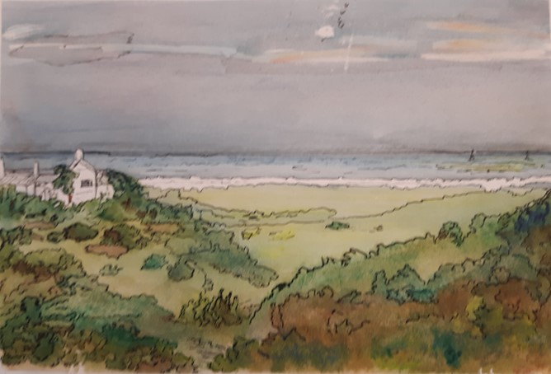 | 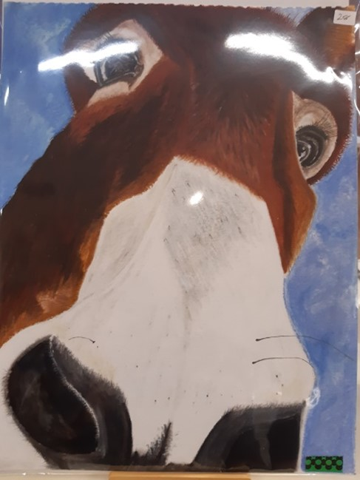
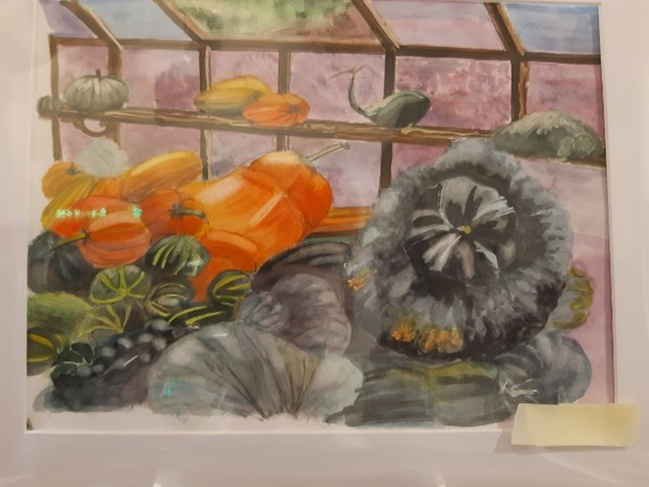 | 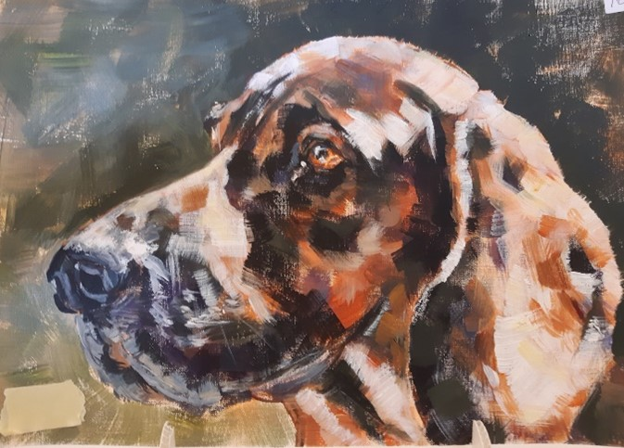
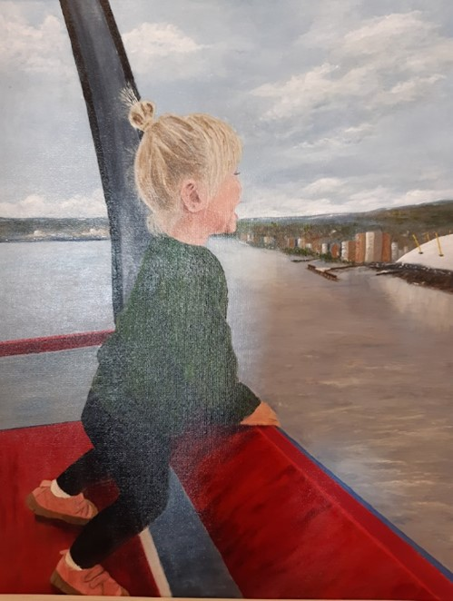 | 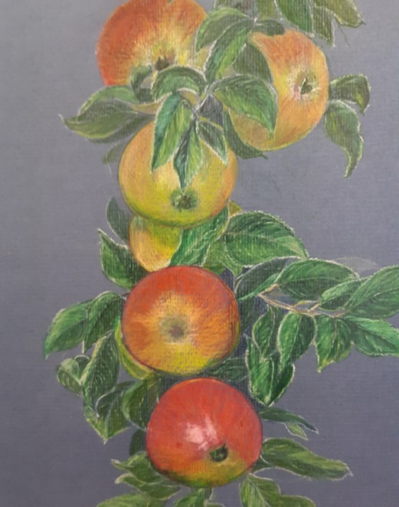
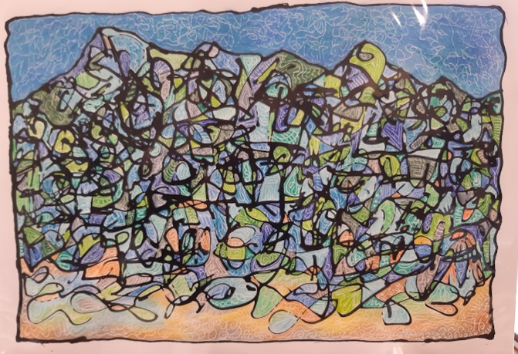 | 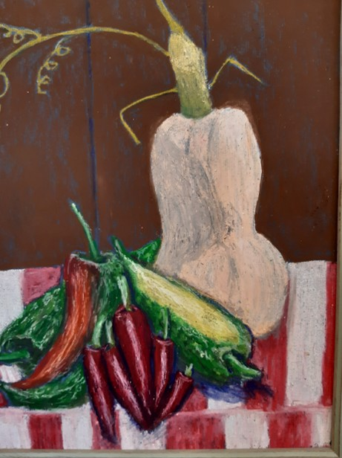
There was also a Christmas quiz, which had quite a few people scratching their heads over the answers, as some required an educated guess! The Winner of this was Jo Hendon who won a box of chocolates. Well done Jo!

Other News and stepping into 2024

BAS Committee

The AGM is fast approaching (3 February 2024) and thought must be given to the election of a new Committee. In the previous Bulletin, we gave notice that the current Committee will be stepping down.

Therefore, the key/major positions that will require filling at the AGM in February 2024 will be:

Chair
Secretary
Treasurer
Membership Secretary
Exhibition Secretary
Refreshments Co-Ordinator
Website/Facebook Co-Ordinator

The current Committee would be happy to mentor the new Committee in their roles.

Expressions of interest will be required as soon as possible and certainly before the AGM as otherwise, a decision will need to be made regarding the continuing existence of Bexhill Art Society.

Rother Grant – DWLP Spring Exhibition 2024 – grant may be discontinued
We were able to supply Rother District Council with excellent feedback following our successful 2023 Summer Exhibition. However, following this, we were recently advised by RDC that the grant we have received in the past to help fund the Exhibition, may not be available in 2024 due to pressures on Council budgets. It is possible that we may not have further information on this until we next apply for the Grant.

OUR NEXT MONTHLY MEETING IS ON SATURDAY 6 JANUARY 2024
St Augustine’s Church Hall

This is an additional Meeting – we ordinarily don’t meet in January, but the purpose of this meeting is to chase any lingering post-Christmas Blues away and bounce us cheerfully into 2024.

We won’t be having a Demonstrator at this meeting – it’s going to be purely practical, quite informal– and hopefully, fun!

There will be three options available.

Still Life
In one part of the hall, there will be a Still Life set up. Members can paint or draw from one, or different angles by moving around.

Portraiture
Self portraits or studies of others around you. It’s possible that Members will be invited to be models for short poses.

Painting swap
Got a painting that you’ve left half finished because you disliked it or got bored with it? Don’t mind what happens to it? Bring it along to the meeting – all such paintings will be put in a ‘draw’ and whatever painting you get (not your own!) you will work on, doing your own ‘thing’. Paintings should be either acrylics or watercolours.

Materials

For all sections, you’re welcome to bring along acrylics, watercolours and/or pencils and charcoals. No oils please. We would also suggest you don’t bring too many materials - after all, the afternoon session is only two hours with a break for tea so don’t overload yourself. Keep it relatively simple

Please note you will need to take any mucky acrylic palettes and brushes home with you to clean so bring something to put them in.

And FINALLY….from Val Sprott, Acting Chair

This has been an exciting year, replete with great demonstrations, competitions, Artists of the Month, Workshops, several new Members (welcome once again) and a wonderful, successful Exhibition which provided Members with the opportunity to show off (and sell) their excellent work to its best advantage.

We would like to thank you all for taking part in everything that has happened this year, including the demonstrations (as well as improvisations)! A Society is only as good as its Membership so it was lovely to see people pitching in when there were interactive opportunities.

Speaking for myself, I would personally like to thank the rest of the Committee, Marilia, Carol and Claudie for their commitment during 2023.

I would also, on behalf of BAS, like to thank volunteers Jan McIntosh for her sterling work in organising the Demonstrators and Workshops, Julia Hall and Chris Verrijden, for their enthusiastic organisation of the sales table and donations, Jenny Geering for her continuous expert website support and Tim O’Sullivan for always being there to sort out the sound system. All of them also helped out in other ways, including setting up at the Monthly meetings. You’re Golden, you are!

Our thanks also to Saint Augustine’s Church for the use of the Hall for many years now. Especial thanks to Jill at St Augustine’s for her support and prompt response to any of our queries and enquiries.

I’d also like to thank Jayne Ingles, our previous Chair, who had to stand down for personal reasons but who consented to become our Patron. Thank you Jayne.

There will be changes in 2024, that is certain, but it is to be hoped that the New Year will bring many exciting opportunities for Members to enjoy.

In the interim however and on behalf of the BAS Committee, it is my pleasure to wish you all a joyful Christmas and a healthy, happy, prosperous New Year filled with creativity and glorious works of art!

Val Sprott
Acting Chair/Secretary
Bexhill Art Society.

How to contact Bexhill Art Society
Email: bexhillartsociety@hotmail.com

