**THE BEXHILL ART SOCIETY BULLETIN – September 2023**

Wow! What a month August was – and leading into September, it’s looking to be pretty spectacular then as well! This is going to be a **BUMPER BULLETIN!**

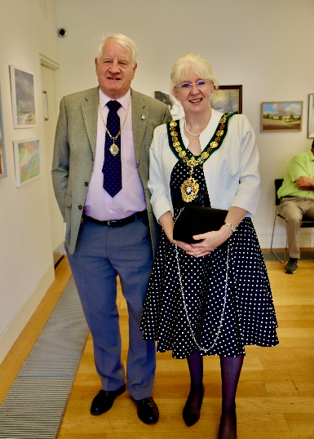

A sizeable proportion of our members exhibited at the Summer Exhibition, held at the De La Warr Studio and opened by the Mayor of Bexhill, Councillor Lynn Brailsford.

Many that did not exhibit will, hopefully at least have visited it.

It was, as many will know, a great success and some interesting facts and figures are provided for you with this Bulletin.

In a nutshell, we had 1026 visitors over the three-day period. 21 of the exhibiting artists sold paintings, browser items or cards and despite the high cost of exhibiting at the De La Warr, BAS ended up with a surplus of just over £300.

Feedback was generally highly positive, with many complimenting the Society on the high quality of work as well as the excellent presentation of the exhibits (this last is entirely down to the professionalism and sensitive management of the specialist ‘hanging team’ used by the De La Warr. As they’re the professionals we left them to make their own choices and just ‘get on with it’ – and get on with it they did!)

|  |  |
| --- | --- |
| Footfall | 1026 |
| Number of exhibits entered (excluding cards) | 136 |
| Number of BAS Members entered | 29 |
| Number of Cards sold | 141 |
| Number of BAS Members who sold their artwork  (Hanging, Browser or Cards) | 21 |
| Number of Hanging paintings sold | 23 |
| Number of Browser paintings sold | 12 |
| New memberships | 6 |
| Number of stewards at the Exhibition | 19 |
|  |  |

The Stewarding also received a lot of comments – visitors reporting that they were delighted with the friendly, cheerful stewards who were happy to talk about the exhibits, answer questions and discuss art in general. It really added to the ambience and the Exhibition always seemed to have a ‘buzz’ about it.

The Winners for the **De La Warr Prize, the Mayor’s Choice Prize, the Visitor’s Choice Prize and the Judges of Hastings Prize** are listed below. Well done to all!

|  |  |  |  |
| --- | --- | --- | --- |
| **De La Warr Prize – Val Sprott**  **Judges of Hastings Prize – Val Sprott** |  |  | |
| **Mayor’s Choice Prize – Bill Greenhead**  **(in fact the Mayor liked Bill’s painting so much, she bought it!)** |  | | |
| **Visitor’s Choice Prize – Jan McIntosh** |  | |  |

The Exhibition was graced by a totally unexpected visit from Terry Carter, the founder of Bexhill Art Society over 60 years ago. He was very complimentary about the exhibition and it was a delightful piece of serendipity when his raffle ticket was the one that won the prize when the draw took place on Monday afternoon.

All in all, a wonderful event – a huge **THANK YOU** to all the artists who entered work!

Saturday 2 September Monthly Meeting

It was a packed hall on Saturday 2 September with a large and enthusiastic gathering for the pastel portrait demonstration provided by Brighton artist Debbie Hinks.

Members were invited to bring their own materials along to take part if they should wish to do so, (some of their work is shown below) although many just sat, fascinated as Debbie worked her magic to bring forth a beautiful portrait.

|  |  |
| --- | --- |
| Debbie showing an example of her work | Close up of Debbie’s beautiful pastel portrait |

The quality of the pastel work was wonderful, although Debbie also touched upon the use of charcoal as well as using both mediums with acrylic. Debbie also showed examples of other portraiture she had done – some breathtaking images were extremely inspiring.

It was really pleasing that several members took part. Below are some examples of their excellent work.

|  |
| --- |
|  |
|  |
|  |

Well done on taking part, and we hope that those who did, enjoyed the experience and felt they learnt something from it.

**August Competition – Self Portrait**

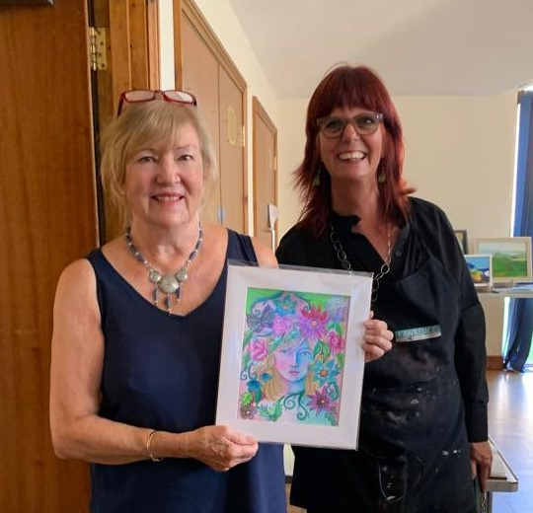

**Stella Mance** was the winner of the Monthly Competition – Self Portrait. Her joyous painting with it’s lovely colours and design was much admired by Debbie Hinks our visiting Demonstrator. Well done Stella!

|  |
| --- |
| **Stella’s Winning Self Portrait** |
|  |
| **Other entries for the self-portrait competition. Thank you to all those who entered!** |

**Artist of the Month – Jo Hendon**

**Jo Hendon**  displayed some of her beautifully colourful paintings and also shared some of her sketch books with members. The paintings looked lovely and were much admired.

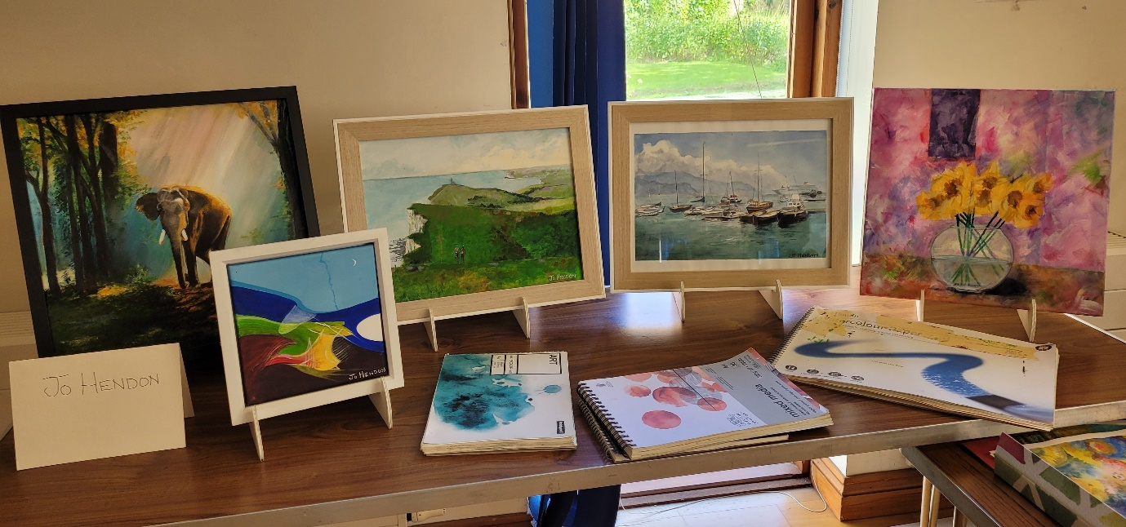

(Further information with more images are on our Facebook page) <https://www.facebook.com/bexhillartsociety/>

**NOTICES FROM 2 SEPTEMBER MEETING**

**Extracts from Val Sprott’s presentation as Acting Chair**

**De La Warr Exhibition**

The De La Warr Exhibition was a great success resulting in a surplus of over £300. A summary of the facts and figures was supplied at the meeting (and will be attached to the Bulletin)

It’s known that the De La Warr Studio has always been a gamble.

It’s in an excellent position for passing footfall, but very expensive to rent. As a Committee, we had concerns about the money that needed to be expended on the exhibition although it would be alleviated in part by the grant from Rother that we were successful in obtaining, the entry fees and, we hoped, the commissions from any paintings sold.

Eventually, and based on feedback regarding previous exhibitions, we relied on unpaid advertising wherever we could find it and in fact most footfall was as the result of the Promenade posters, the De La Warr advertising and our roadside banners for people ‘just passing by’. Online advertising on such sites such as Facebook and Rother Alerts was also extremely important. It was notable that hardly any visitor attended as the result of the printed flyers and A4 posters that were created.

The money saved on paid advertising was used to pay for professional hanging of the paintings at the Exhibition. The result, I think you’ll agree, was impressive. The excellent hanging showed the work off to it’s best advantage and it was much commented upon.

The Exhibition should be counted as a great success, yet only 29 artists from a membership of over 80, entered. There is a great deal of food for thought and analysis over the coming weeks and months.

During the exhibition, we were thrilled that Terry Carter, the founder of BAS visited, without any prior notice – he just came in quietly to look around. He told me later how much he had enjoyed the exhibition and It was one of serendipitous moments that when the raffle was called, it was HIS raffle ticket that was pulled out of the huge pile in the bucket. Quite amazing!

Val thanked the following:

All of the 19 stewards for the time and energy they put into being at the Exhibition. A comment that recurred on several occasion was how helpful, friendly and knowledgeable they were.

Neil Buchanan and Martin Sutton – Neil for his advice and feedback regarding previous exhibitions and for his kind assistance in checking the entries on Hand in Day. Martin for his great help in creating the poster design, advice and sorting out the Exhibition equipment. (Val later made reference to an Open Studio that both of them are holding 2/3 and 9/10 September as part of the Coastal Currents Event).

Jan McIntosh – Jan served on the previous Committee for several years, yet after standing down, came back to us firstly back on the committee, then after standing down after a year, as a volunteer, to assist in all sorts of practical ways, including providing advice on the Exhibition and useful, constructive suggestions.

Jayne Ingles - Jayne had to stand down as Chair because of personal matters but is now our Patron and she kindly came over on the last day to present the Visitor’s Choice Award to Jan.

Val stated she was extremely proud of the small Committee, Marilia Whittome Carol Theron and Claudie Harbour and thanked them all individually.

Claudie had to step back because of health issues but remained on the Committee providing advice and support wherever possible. She is an essential voice on the Committee and has now returned to continue within her position.

Carol was not only heavily involved in all the discussions, preparations and facilitation for the exhibition, but also stepped up to take over the refreshments due to Claudie’s indisposition. Her forthright and honest feedback and constructive suggestions are highly valued within the Committee.

Marilia – As well as being Treasurer, Marilia had to don several other hats in order to ensure the exhibition took place successfully. It’s unlikely it would have happened without her utterly dedicated commitment. Her professionalism, document creation and preparation, double checking, liaison with other parties and strong, logical and organisational skills helped ensure the successful start, running and conclusion of the Exhibition.

After Val had finished her thanks, Marilia stood to thank Val on behalf of BAS and the Committee stating that none of the above would have been possible without her highly competent leadership.

**The Raffle and Sales Table**

The raffle in August achieved £26 and the sales table took a stonking £75. Well done to Julia and Christine for running the Sales Table with such enthusiasm – thank you – and dear Members, please do bringing in your unwanted items so that they can find a loving home elsewhere!

**Possible Arts and Crafts Sale 11 November Cancelled**

We have decided not to pursue the idea of an Art and Crafts Sale on 11th November on this occasion. This will not affect the Workshop being run by Josie Tipler on the same day, in the small hall – more information on this will be provided by Jan.

**Volunteers**

We had several new members attend the September meeting. **Welcome to you all!**

This is great news and also a good opportunity to remind Members that we would welcome volunteers for various options including befriending new members who may feel a little lost or awkward if they don’t know anyone, or buddying those who may have difficulty sending in or picking up paintings, whether at Exhibitions. Please speak to any of the Committee.

**Workshops**

Jan will be reminding members of the details of the last Workshop of the year to take place on 11 November with Josie Tipler – experimenting with acrylics in unusual ways. Jan is also in the process of considering demonstrators and workshops for 2024 and is always pleased to hear from Members who have contacts and ideas that they might like to pass on.

**So, here we are in September, the first month of Autumn. The leaves turn, the harvest is gathered in, squirrels run hither and thither stocking their winter larders……..and of course –**

**OUR NEXT MONTHLY MEETING IS ON SATURDAY 7 OCTOBER**

**St Augustine’s Church Hall**

**The Demonstration**

September’s demonstration will be by Lesley Smith, a locally based highly proficient botanical watercolourist and tutor. She will be sharing some of her hints and tips in the best use of Watercolours and possibly touching upon the use of gold in her paintings. Members are welcome to bring their own watercolours (not too many materials please – just a watercolour pad, small box of colours and something to protect your area of any table you use) and to do some experimentation themselves.

**Monthly Members’ Art Competition – Title: View from my Window**

So – this could be the view from your window across verdant acres, or maybe of your flourishing window box, the street outside or the clothesline…..or it could be the view you’d **LIKE** from your window! Up to you so get creative! Remember, there’s a prize of £15 for the winner.

**Artist of the Month -October**

Tricia Williams will be our Artist of the month and we look forward to admiring some of her work.

We have members booked as Artist of the Month until November and we will then be looking towards 2024, from March onwards. Please don’t hide your light under the bushel – speak to any of the Committee if you are interested in putting yourself forward for any month next year. Members love to view each other’s work and because we all work in different styles, ideas, and hints and tips are shared and discussed.

**How to contact Bexhill Art Society**

Email: [bexhillartsociety@hotmail.com](mailto:bexhillartsociety@hotmail.com)